1.85: a) 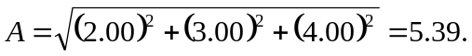
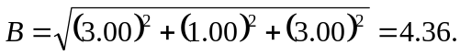

b) 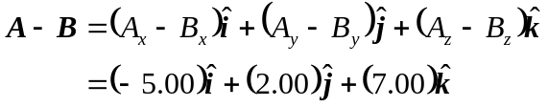

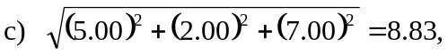

and this will be the magnitude of 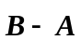as well.

